**Lab 6: Design and Implement a VLSM addressing scheme**

Course Code - Course Name: - COMP4039 – Network Foundations

Program: T433 - Cybersecurity

Section: A

Term: - Winter 2024

Group Number: 06

Student Names - ID:

* Prabhjot Singh Sains – 101495218
* Rahul Patel - 101378458
* Jai Deep Rawat - 101503760
* M. Salmaan Mustafa Shah – 10151007

Lab Report by - Prabhjot Singh Sains

**Topology**

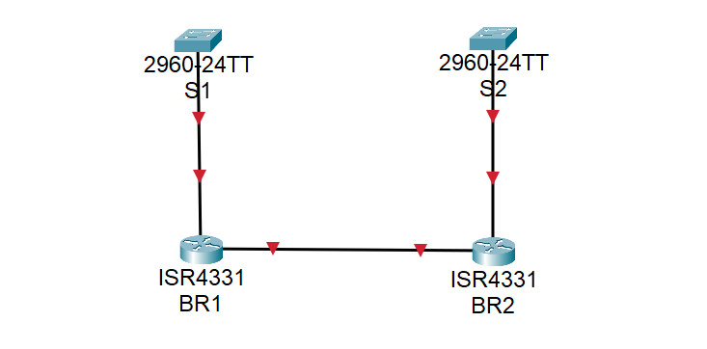

Fig. 1- Topology

**Part A: Design the VLSM address Scheme:**

1. Examine the network requirements to develop a VLSM address scheme for the network displayed in the topology diagram using the **192.168.33.128/25** network address.
2. Use the information obtained in Step 1 to fill in the following table.

|  |  |  |  |  |
| --- | --- | --- | --- | --- |
| **Device** | **#of hosts** | **Network address /CIDR** | **The first host add** | **Broadcast add** |
| **BR1 LAN** | **40** | **192.168.33.128/26** | **192.168.33.129/26** | **192.168.33.191/26** |
| **BR2 LAN** | **25** | **192.168.33.192/27** | **192.168.33.193/27** | **192.168.33.223/27** |
| **BR2 IOT LAN** | **5** | **192.168.33.224/29** | **192.168.33.225/29** | **192.168.33.231/29** |
| **BR2 CCTV LAN** | **4** | **192.168.33.232/29** | **192.168.33.233/29** | **192.168.33.239/29** |
| **BR2 HVAC LAN** | **4** | **192.168.33.240/29** | **192.168.33.241/29** | **192.168.33.247/29** |
| **BR1-BR2 Link** | **2** | **192.168.33.248/30** | **192.168.33.249/30** | **192.168.33.251/30** |

**Part B: Set up the topology and initialize the devices:**

1. Cable the network as shown in the topology diagram and turn on your devices.
2. Establish a console connection to all devices then Initialize and reload to clear any existing configuration using the following commands:

For switches:

Switch> enable

Switch# delete vlan.dat

Switch# erase startup-config

Switch# reload

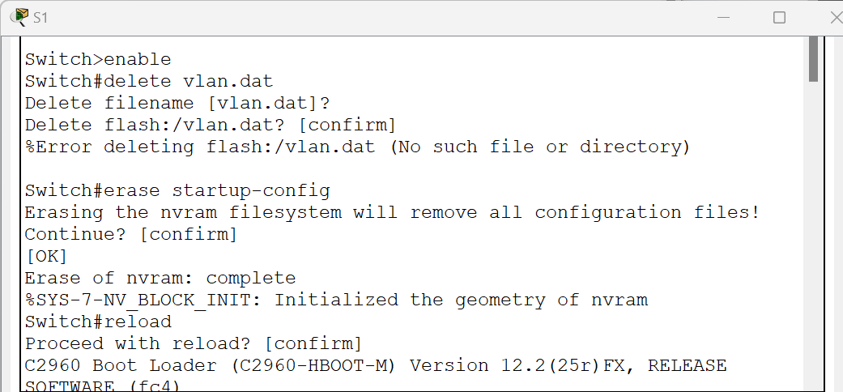

Fig. 2- Switch 1

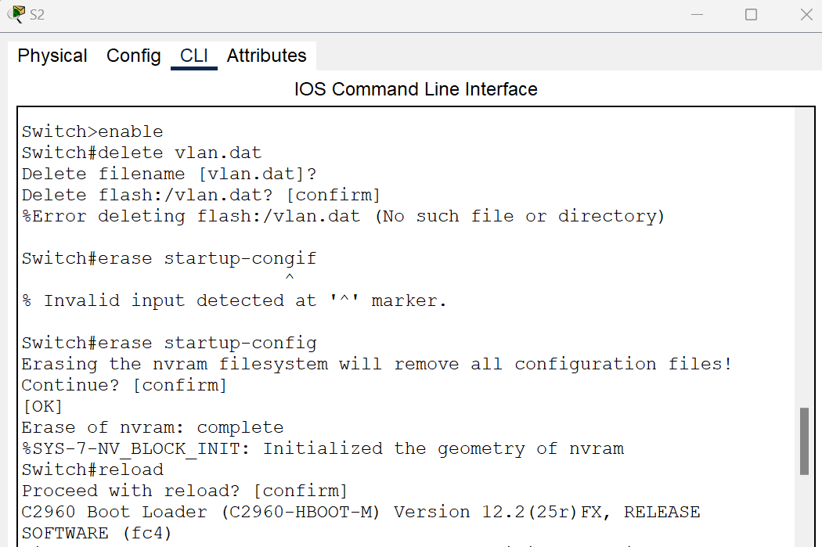

Fig. 3- Switch 2

For routers:

Router> enable

Router# erase startup-config

Router# reload

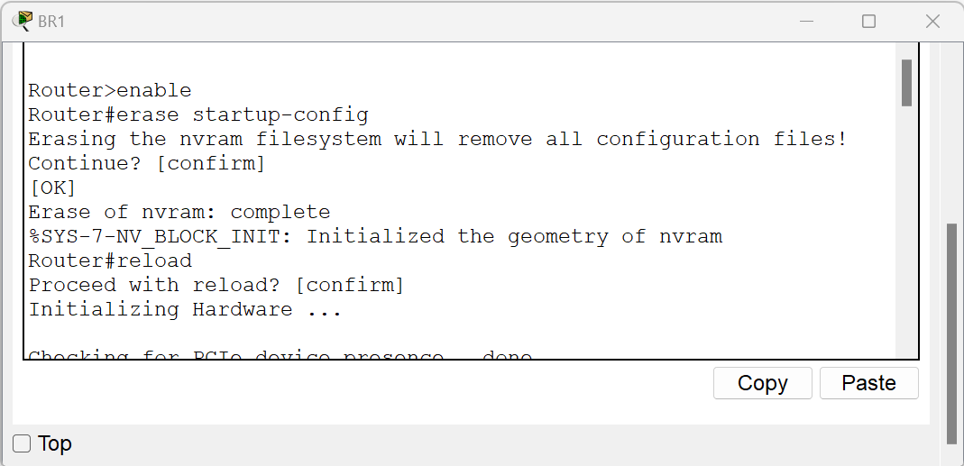

Fig. 4- Router - BR 1

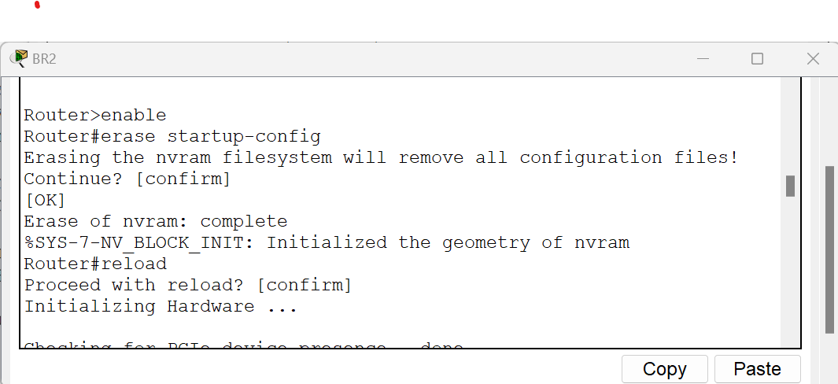

Fig. 5- Router - BR 2

**Part C: Configure basic settings on each Router:**

1. Change the router's name to BR1 and BR2.

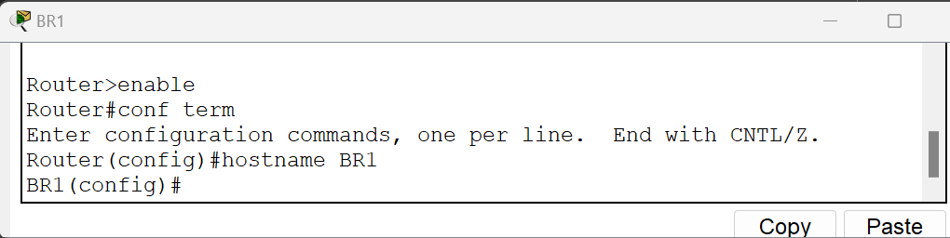

Fig. 6- Router - BR1

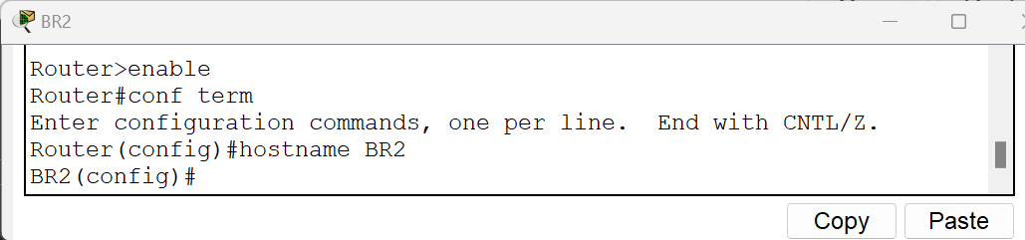

**Fig. 7- Router – BR2**

1. Disable DNS lookup to prevent unwanted DNS lookups.

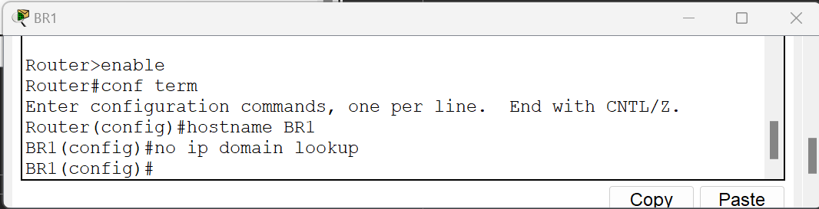

Fig. 8- Router – BR1

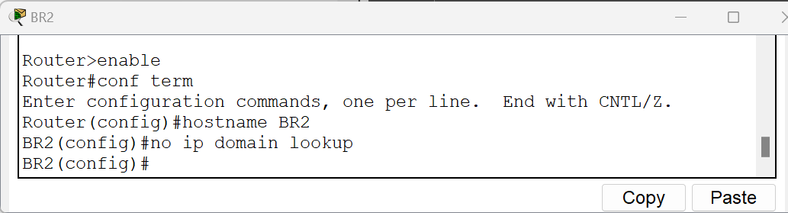

Fig. 9- Router – BR2

1. Assign the **Class** as the privileged EXEC encrypted password.

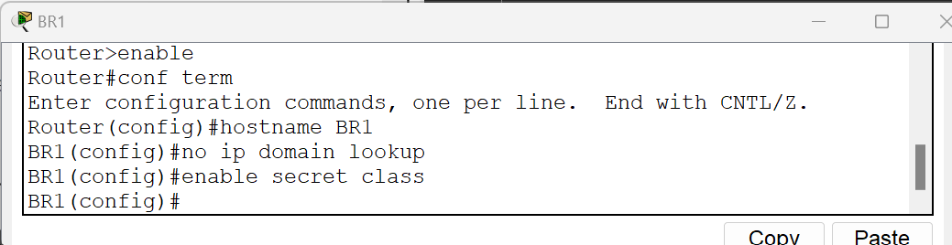

Fig. 10- Router – BR1

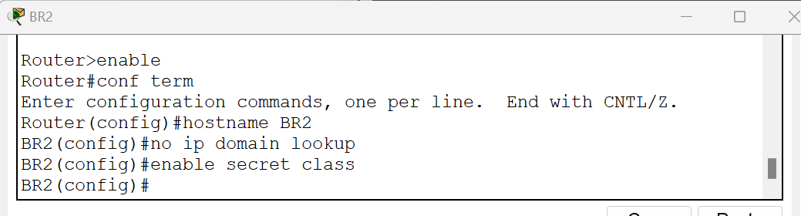

Fig. 11- Router – BR2

1. Assign **Cisco** as the console password and enable login.

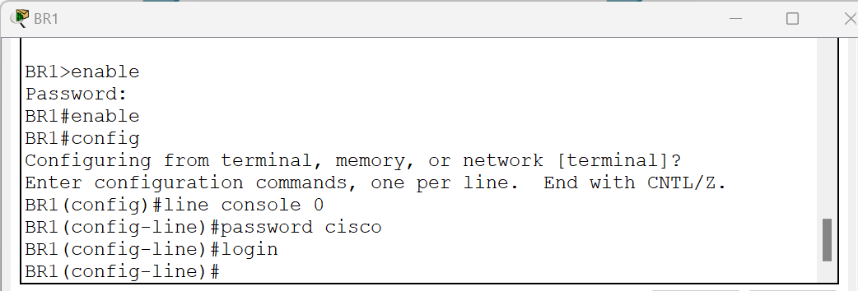

Fig. 12- Router – BR1

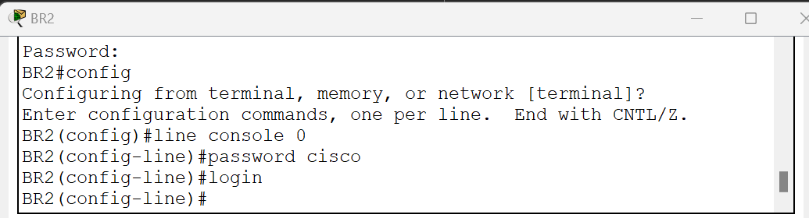

Fig. 13- Router – BR2

1. Assign **Cisco** as the VTY password and enable login.

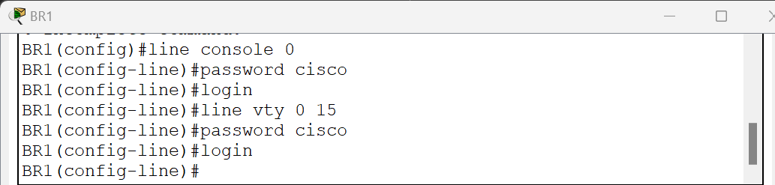

Fig. 14- Router – BR1

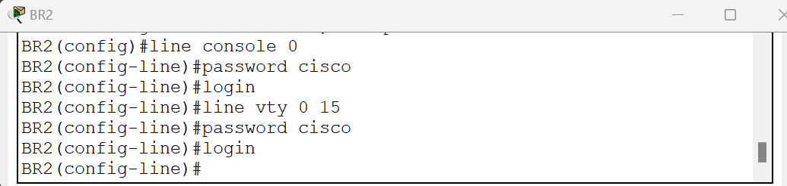

Fig. 15- Router – BR2

1. Encrypt the plaintext passwords.

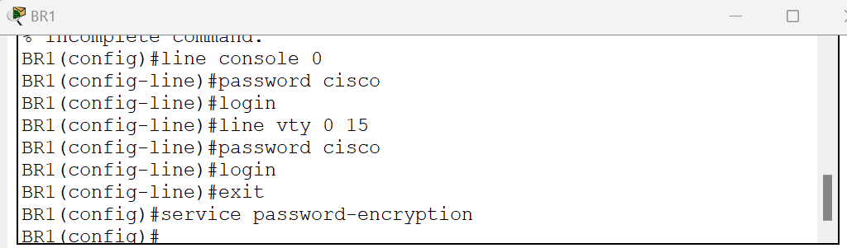

Fig. 16- Router – BR1

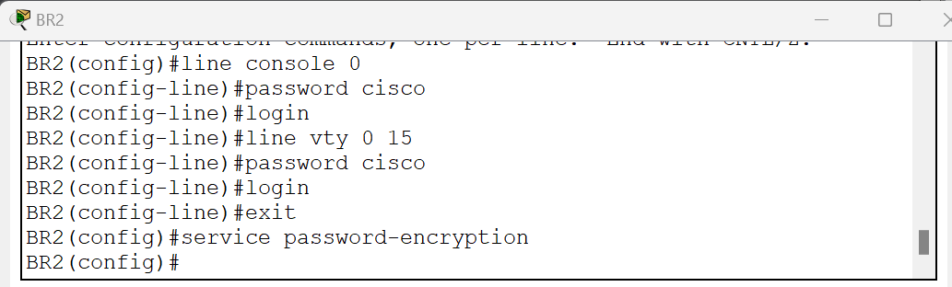

Fig. 17- Router – BR2

1. Create a banner that warns anyone accessing the device that unauthorized access is prohibited.

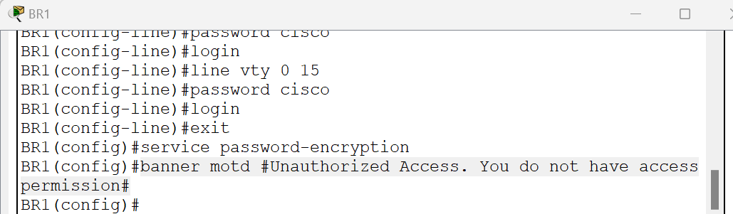

Fig. 18- Router – BR1

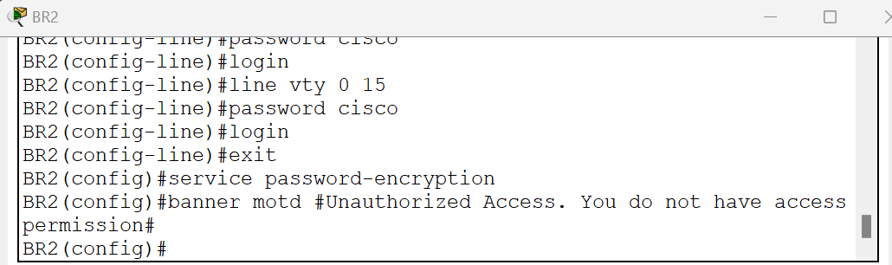

Fig. 19- Router – BR2

1. Save the configuration. Use the copy command to save the running configuration to the startup file on non-volatile random-access memory (NVRAM).

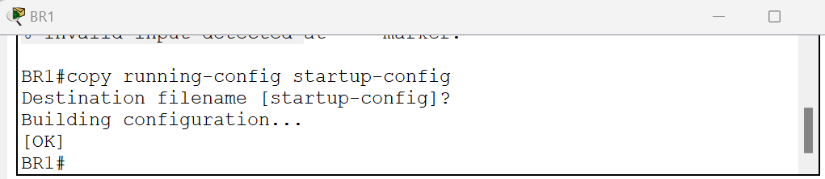

Fig. 20- Router – BR1

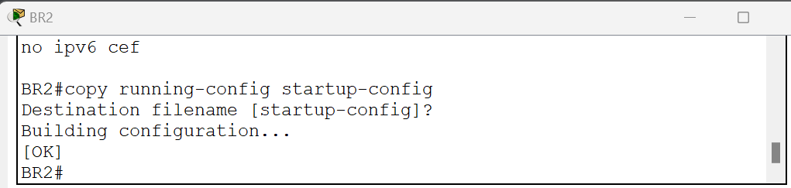

Fig. 21- Router – BR2

**Part D: Configure the interfaces on each router:**

1. Complete the device interface address table:
   1. Consider the following:
      1. Assign the first host address in the subnets (BR1 LAN and BR2 LAN) to the Ethernet interfaces G0/0/1.
      2. BR1 should be assigned the first host address in the BR1-BR2 Link

|  |  |  |  |  |
| --- | --- | --- | --- | --- |
| **Device** | **Interface** | **IP address** | **Subnet Mask** | **Device Interface** |
| **BR1** | G0/0/0 | 192.168.33.249 | 255.255.255.252 | BR1-BR2 Link |
| G0/0/1 | 192.168.33.129 | 255.255.255.192 | 40 Host LAN |
| **BR2** | G0/0/0 | 192.168.33.250 | 255.255.255.252 | BR1-BR2 Link |
| G0/0/1 | 192.168.33.193 | 255.255.255.224 | 1. ost LAN |

1. Configuring IP address and Subnet Mask.

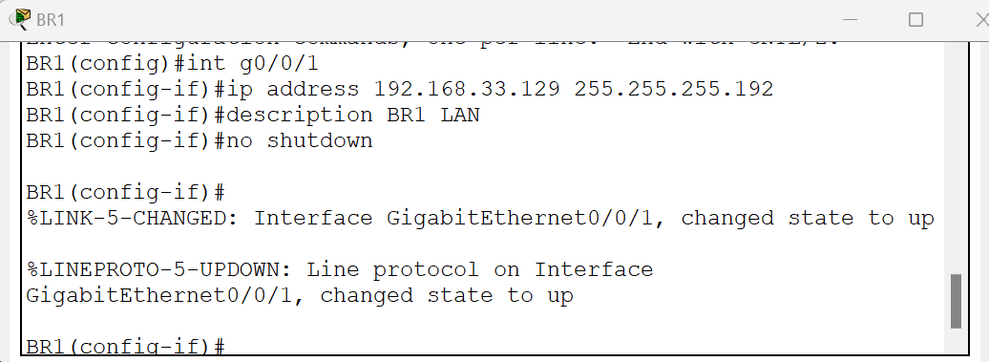

Fig. 22- BR1 – G0/0/1

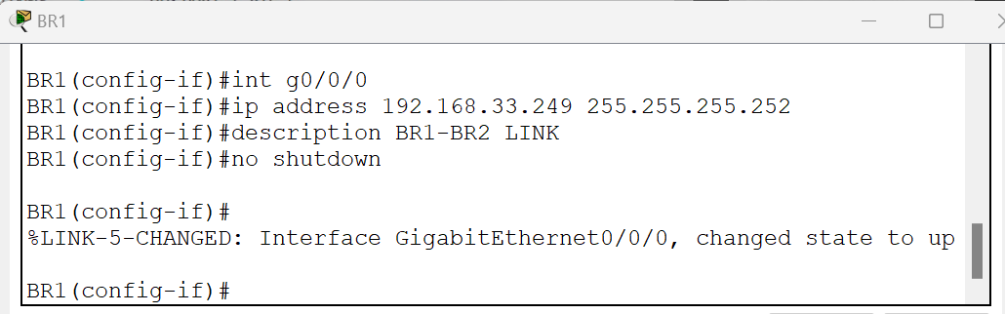

Fig. 23- BR1 – G0/0/0

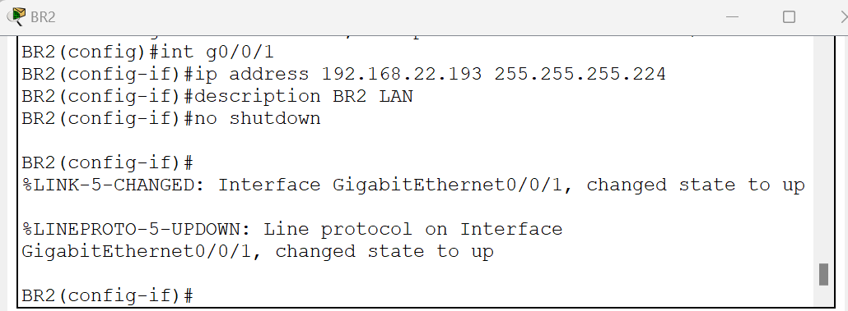

Fig. 24- BR2 – G0/0/1

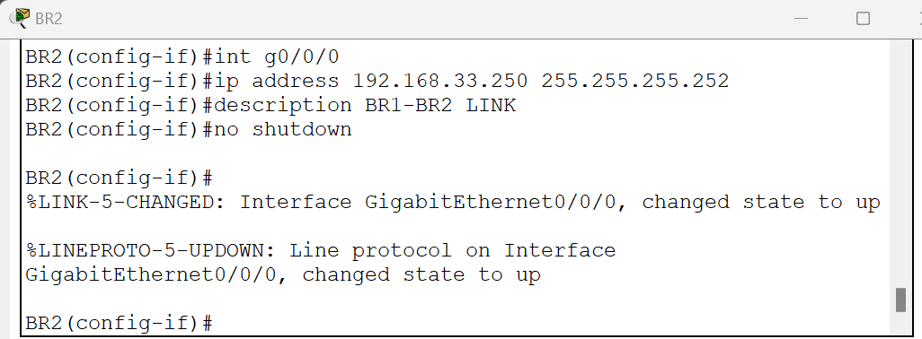

Fig. 25- BR2 – G0/0/0

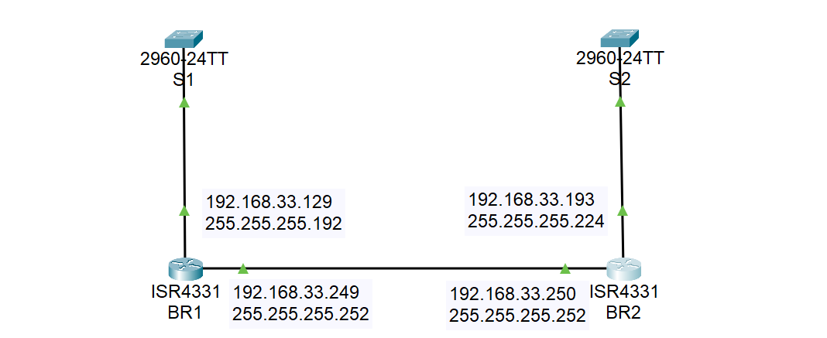

Fig. 26- Topology

1. The output of running command “**show ip interface brief**” on both routers to display the usability status of interfaces configured for various IP addresses.

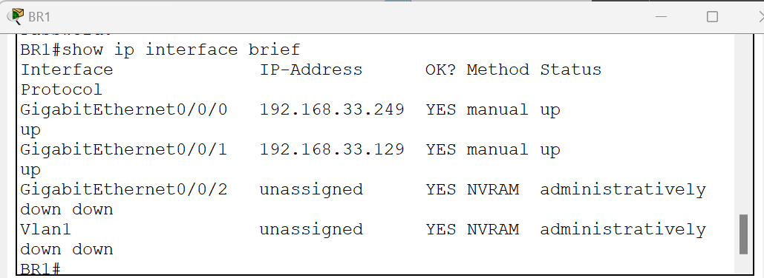

Fig. 27- Router – BR1

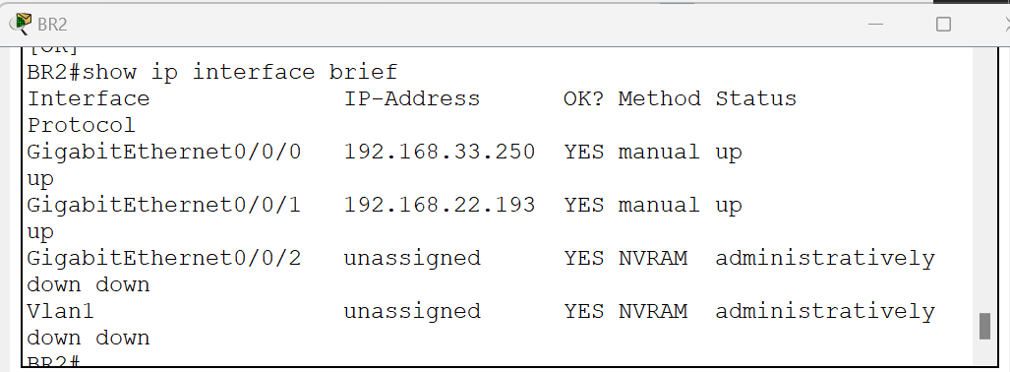

Fig. 28- Router – BR2